**Assignment/Exercise 13 – Heatmap Sales/Product data**

**Open your HTML page in WEB browser and take a screen shot of your page showing page Title (your name) and page background.**

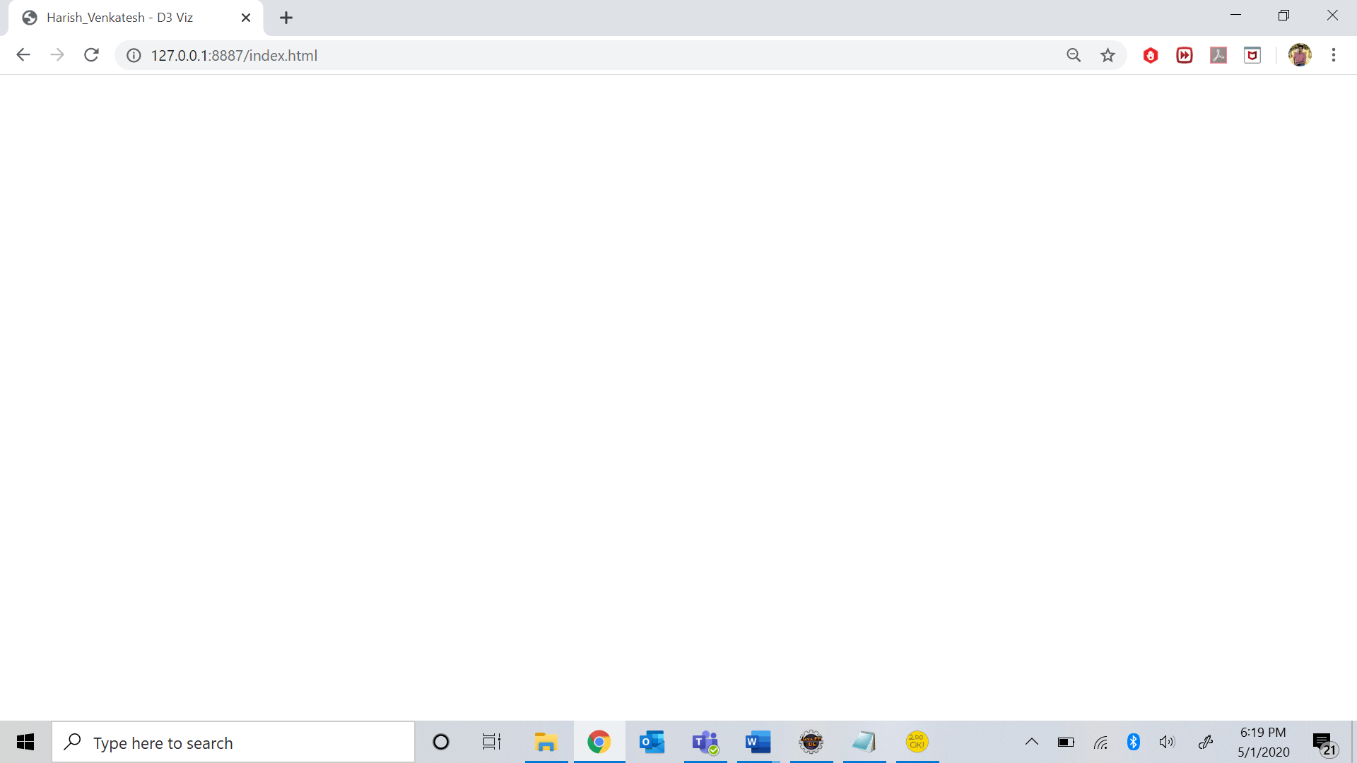

**Adding svg and D3**

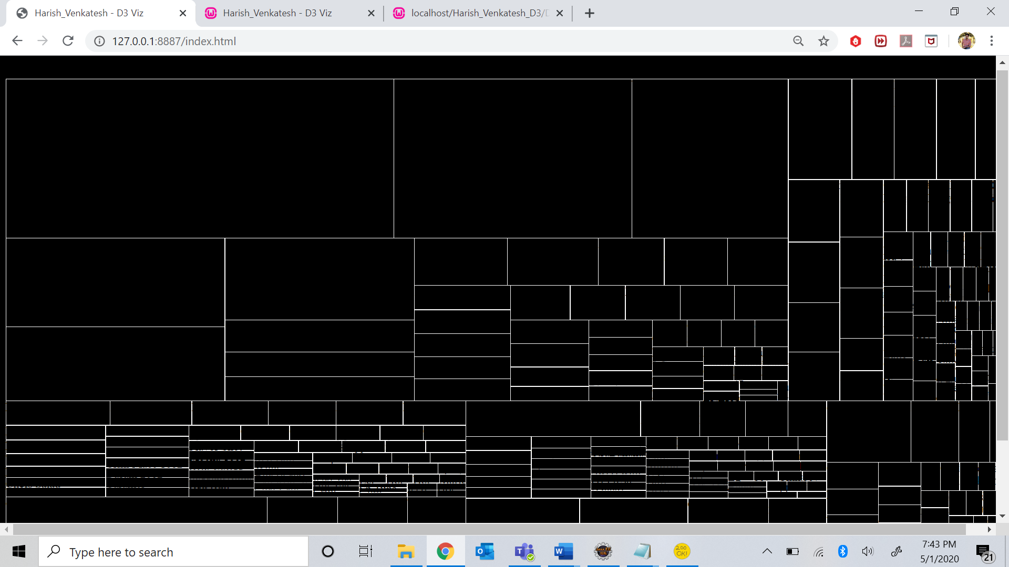

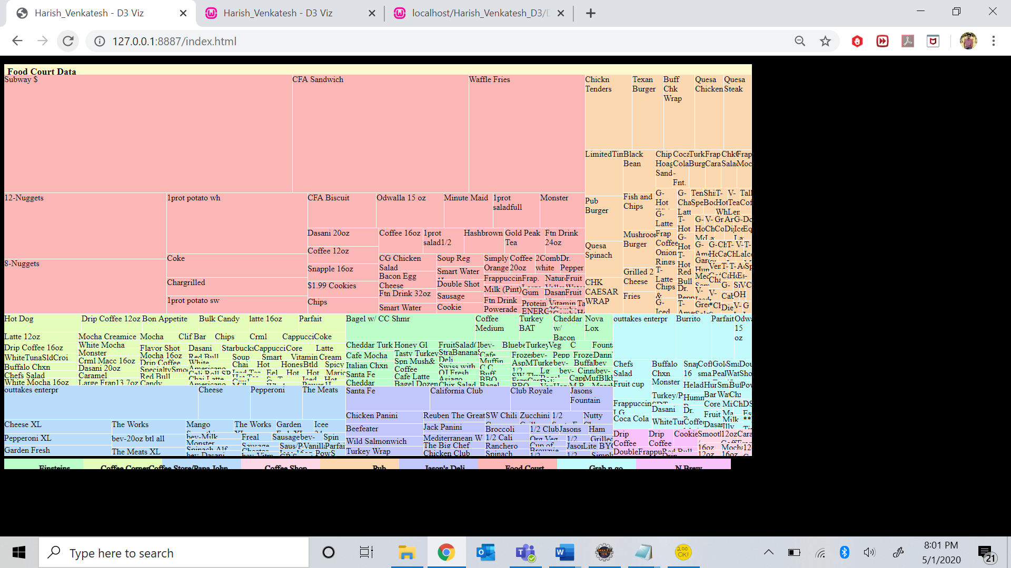

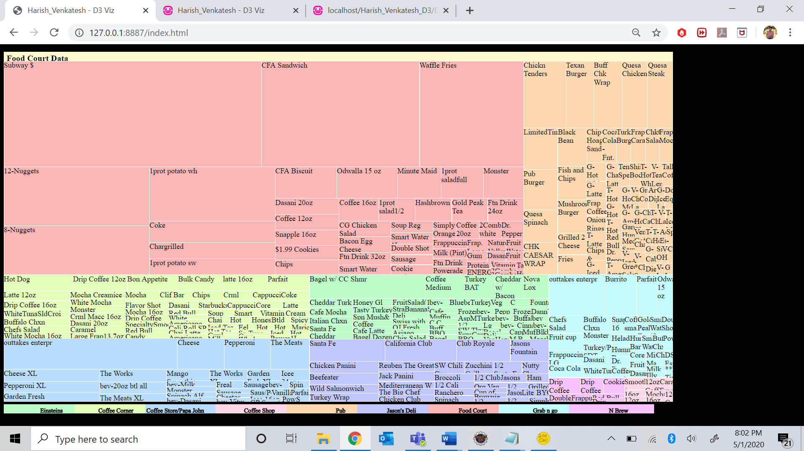

**click anywhere in the rectangle Coffee Store/Papa John.**

